1.
Draw a diagram of a bus topology and label all key components, then write one real-world example where this topology might be used.
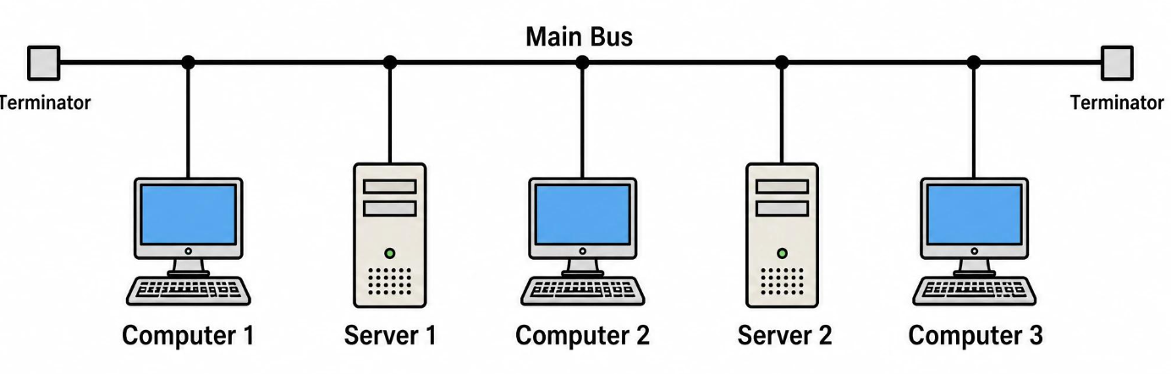
Key components: backbone cable, connecting cables, computers (nodes), and terminators at both ends.
Real-world example: An older Ethernet LAN using 10BASE2 coaxial cable, where multiple computers shared a single backbone cable.

2.
In Cisco Packet Tracer, create a simple star topology with one switch and four PCs connected to it; name each PC after a popular app (e.g., WhatsApp, Zomato, Spotify, Flipkart) and take a screenshot of your topology.
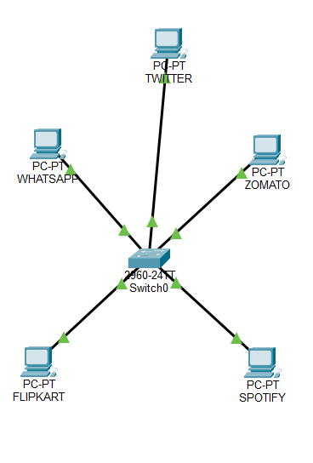

3.
Draw a ring topology diagram and explain in 2-3 sentences how data travels between devices in this setup.<br><br><em><strong>Hint:</strong> Use arrows to show the direction of data flow.</em>
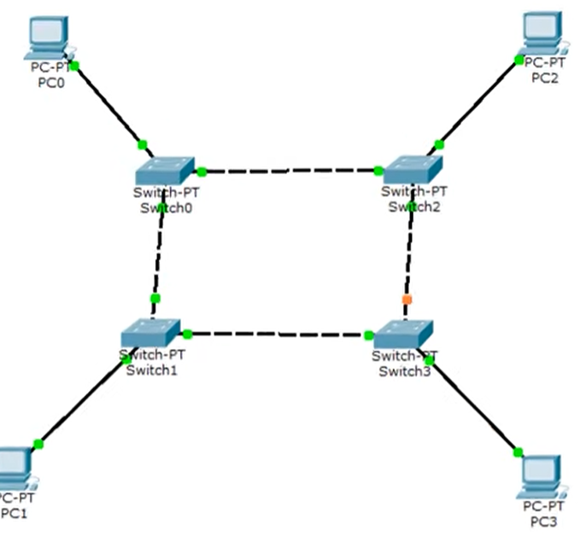
Data travels from one device to the next around the ring in the direction shown by the arrows until it reaches the destination. Each device forwards the data to its neighbor.

4.
Compare mesh and star topologies by listing 2 advantages and 2 disadvantages of each in a table format.
Topology | Advantages (2) | Disadvantages (2)
Mesh | 1. Highly reliable due to multiple paths.  2. Failure of one link may not stop communication. | 1. Requires more cables and ports.  2. Expensive and complex to install.
Star | 1. Easy to install and troubleshoot.  2. Failure of one cable usually affects only one device. | 1. Switch failure can stop the entire network.  2. Requires more cable than some simpler topologies

